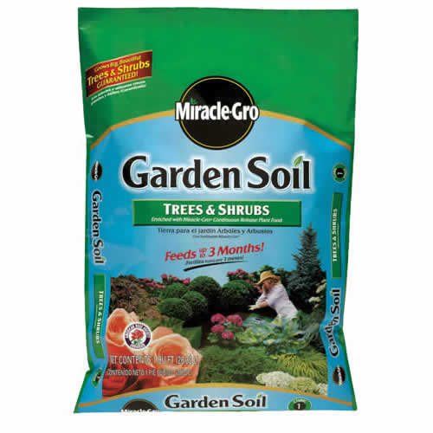
Miracle Grow Tree and Shrubs
- Continuous release food
- Builds strong roots
#32
- 1 Cubic Foot
$2.49
7204076

